SELLER PERFORMANCE & DELIVERY REVIEW

Data Analytics Catalogue

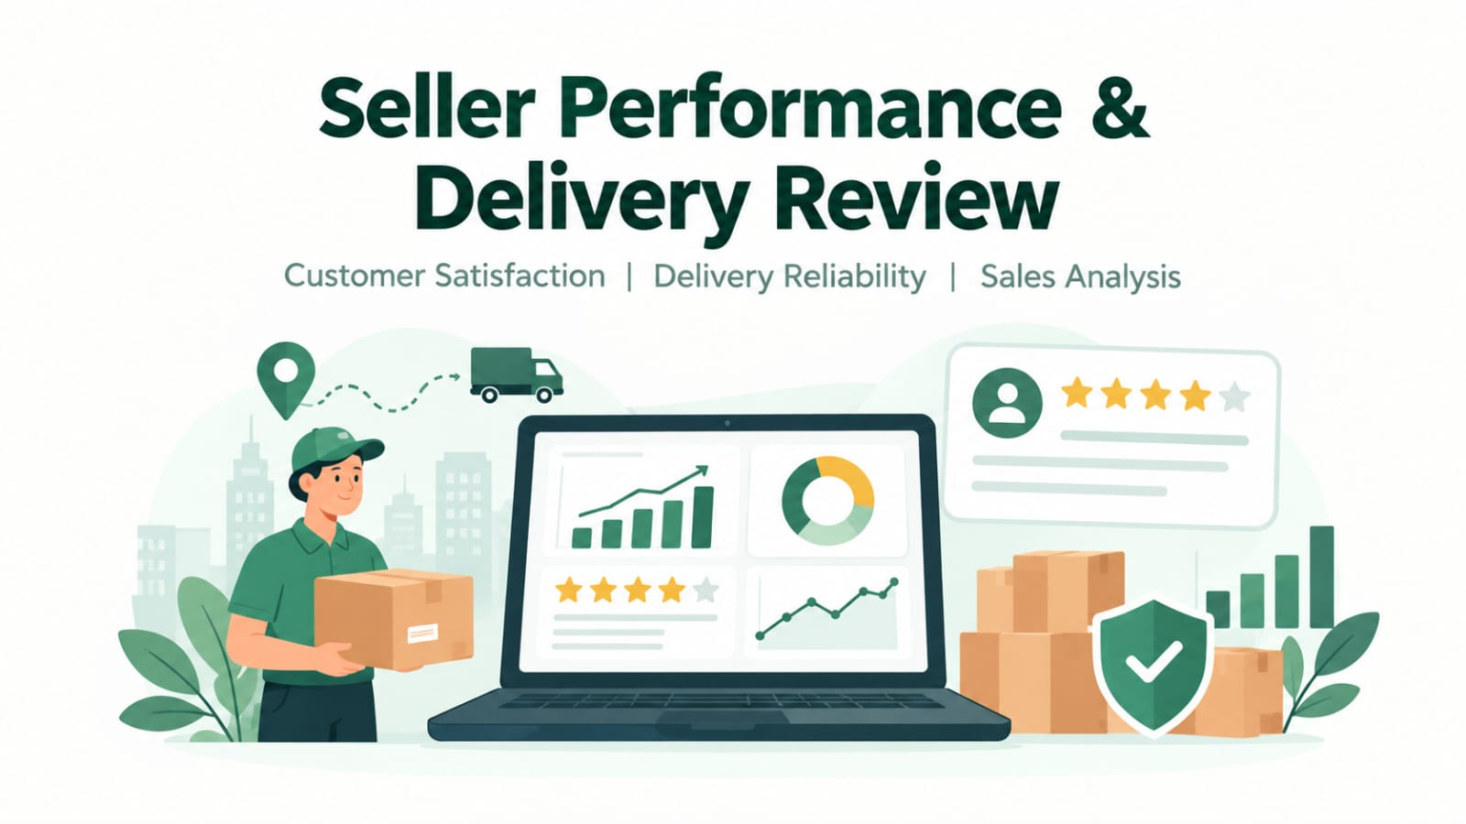

1.Introduction

In the e-commerce industry, customer satisfaction and reliable delivery play an important role in business success. Customers expect products to arrive on time and meet their expectations. Poor delivery performance and low customer ratings can negatively affect customer trust and business reputation.
This project analyzes e-commerce order, product, review, and delivery data to understand customer satisfaction, delivery performance, and sales trends. Data analysis and visualization are used to identify areas that may require improvement.

2. Problem Statement
E-commerce businesses need to understand the factors associated with low customer ratings and delayed deliveries. Without proper analysis, it can be difficult to identify products, categories, or geographical areas where performance needs improvement.
The purpose of this project is to analyze available order and review data to identify patterns in customer ratings, delivery delays, and sales performance. The findings will support data-driven recommendations to improve customer satisfaction and delivery reliability.

3. Project Objectives
The main objectives of this project are:
- Analyze customer ratings and review scores.
- Examine delivery delays and delivery performance.
- Identify product categories associated with lower customer ratings.
- Compare delivery performance across customer states.
- Analyze sales performance across product categories.
- Examine the relationship between delivery delays and customer ratings.
- Develop an interactive Power BI dashboard to present key findings.
- Provide recommendations for improving customer satisfaction and delivery performance.

4. Business Questions
This project aims to answer the following questions:
- Which product categories have the lowest customer ratings?
- Which customer states have higher delivery delay rates?
- How many orders were delayed?
- What percentage of orders were delayed?
- Is there an association between delivery delays and customer ratings?
- How are customer review scores distributed?
- Which product categories generate the highest sales?
- Which states have the highest numbers of low-rated orders?
- What areas of delivery and customer experience need improvement?

5. Dataset Description
The project uses an e-commerce dataset containing information about orders, products, customer reviews, and delivery performance.
The dataset may include fields such as:
- Order ID
- Order purchase timestamp
- Order delivery date
- Estimated delivery date
- Customer state
- Product category
- Review score
- Sales or payment value, where available
The exact fields and number of records depend on the dataset used in the analysis. Only columns present in the actual dataset are included in the analysis.

6. Tools and Technologies
The following tools are used for this project:
- Microsoft Excel: Initial data inspection and spreadsheet operations.
- SQL: Querying data and calculating performance metrics.
- Python: Data cleaning, exploratory data analysis, and visualization.
- Power BI: Interactive dashboards and business performance reporting.

7. Project Methodology
The project follows these steps:
- Data Collection: Obtain the e-commerce dataset from Kaggle.
- Data Inspection: Review the columns, data types, missing values, and duplicate records.
- Data Cleaning: Correct data types and handle data-quality issues where necessary.
- SQL Analysis: Write queries to summarize orders, ratings, delivery delays, and sales.
- Exploratory Data Analysis: Use Python to examine patterns and create visualizations.
- Dashboard Development: Build a Power BI dashboard with charts, KPI cards, and slicers.
- Interpretation: Review the results and identify potential improvement areas.
- Recommendations: Suggest actions based on the evidence in the dataset.

8. Expected Outcomes
The expected outcomes of this project are:
- A clearer understanding of customer ratings and review patterns.
- Identification of product categories with relatively low ratings.
- Analysis of delivery delays and differences across customer states.
- Better visibility into sales performance by product category.
- An interactive dashboard for exploring performance metrics.
- Practical recommendations supported by the analysis.

9. Limitations
The accuracy of the findings depends on the quality and completeness of the dataset. The analysis can identify patterns and associations but does not necessarily establish that delivery delays cause low ratings.
Identifying individual seller performance requires a reliable seller identifier linked to orders and reviews. If individual seller identifiers are unavailable, the analysis will focus on product categories, customer states, and overall delivery performance instead.

10. Conclusion
The Seller Performance & Delivery Review project uses data analysis to investigate customer ratings, delivery reliability, and sales performance in e-commerce. By combining SQL, Python, and Power BI, the project aims to turn raw data into meaningful insights that can support better operational decisions and improvements in the customer experience.

